Privacy Policy 2023/24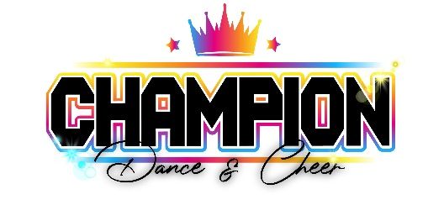
Champion Dance and Cheer is committed to maintaining high standards of the GDPR (General Data Protection Regulation) which the Government has incorporated as law as GDPR alongside the Data Protection Act 2018 following Brexit.
We have put in place appropriate measures to ensure that all student / staff data (or any other data that we hold) is all held securely, and that we only use any personal data in accordance with GDPR guidelines.
- We do not sell personal data to third parties. We do however disclose information on athletes to event providers and travel companies as required.
- We use contact phone numbers/ emails/addresses for communication to athletes/parents including invoices and general information.
- Emergency contact details and medical details are given to Staff for emergency purposes. Medical details may be shared with medical professionals when required in a medical emergency.
- Payment details are collected via ClassForKids - these are secure details which we have no access to share or amend on your behalf.
- Methods of contact made by Champion Dance & Cheer is; Email/Mobile phone/Text/Website/Social media/Whatsapp/App
- Photos and videos taken at class, competitions and events may be used for promotional material such as posters, social media content, flyers etc, we may also use these for broadcast on TV, online or in media such as newspapers. We may use names and ages of athletes.
- Photographs taken, and/or footage filmed during practices and performances may be shared with coaches/athletes/guardians or outside consultants such as choreographers in social media groups/pages for example a team Whatsapp group.
- We may store personal data provided by prospective new members for communication purposes for example, regarding becoming a member of the club
IF AT ANY POINT YOU NO LONGER WISH TO BE CONTACTED BY CHAMPION DANCE & CHEER OR YOU NEED DETAILS UPDATED/AMENDED THE RESPONSIBILITY OF THIS LIES WITH YOU, THE PARENT / GUARDIAN OR ATHLETE IS OVER 18 TO NOTIFY A MEMBER OF STAFF VIA EMAIL OR YOU CAN UPDATE ANY PAYMENT DETAILS THROUGH YOUR CLASSFORKIDS ACCOUNT.
In consideration of me agreeing to these terms and conditions, I am allowing myself / my child, to participate in Champion Dance & Cheer training and events.

